Import Data using Transform Maps (Spreadsheet)
Phase 2: Requirement Analysis Phase

1. Overview
The project requires a ServiceNow instance, an employee spreadsheet and the ServiceNow features needed for importing and processing the data. The main employee fields are Employee ID, Employee Name, Email, Department and Location.
The system should support spreadsheet loading, source-to-target field mapping, transformation, validation and duplicate handling. Coalesce is required to identify existing employee records during repeated imports.

2. Key Activities
- ServiceNow instance.
- Employee spreadsheet with sample data.
- Employee Test custom table.
- Employee Import Import Set table.
- Transform Map for field mapping.
- Employee ID, Name, Email, Department and Location fields.
- Coalesce for duplicate handling.
- Reports and dashboard.
3. Detailed Process
In this phase, the project work related to **Requirement Analysis Phase** is carried out according to the overall ServiceNow project workflow. The activities are recorded in sequence so that the implementation can be understood and demonstrated clearly.

4. Expected Outcome
The phase should produce a clear and documented output that can be verified before moving to the next phase. The project remains focused on importing spreadsheet employee data into ServiceNow using Import Sets and Transform Maps.

5. Project Evidence / Screenshots

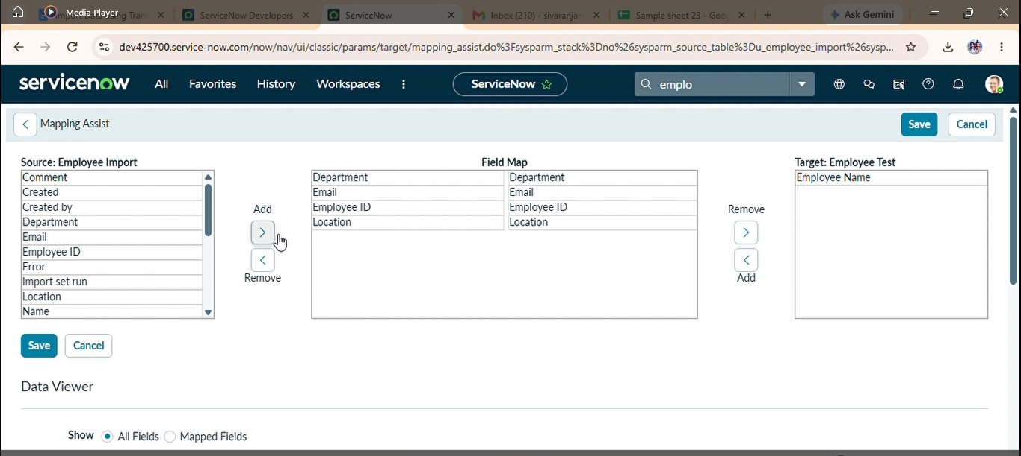

6. Phase Summary
Phase 2 completes the activities required for Requirement Analysis Phase. The documented output and screenshots provide evidence of the project work and support the transition to the next phase.

